UI Flow Specification
  - Chorus: Multi-Output Synchronised Audio Hub
Contents

Field | Value
Document | UI Flow
Product | Chorus: Multi-Output Synchronised Audio Hub
Version | 0.1.0 (Draft)
Status | In development
Last updated | 2026-08-25
Companion documents | PRD · TRD · Schema · User Manual

1. Design Principles
# | Principle | Consequence
P1 | The common case is one control. Ninety percent of use is "make it louder" or "make it quieter". | Master volume is always reachable without navigating anywhere.
P2 | Never claim success that was not verified. | Every action that writes to the audio engine reports only after readback confirmation, and shows a distinct pending state while doing so.
P3 | Degraded is normal, not an error. Wireless outputs drop; that is the medium, not a bug. | A missing speaker is shown as a state on the affected row, never as a modal dialog.
P4 | Numbers, not adjectives. | Latency is shown in milliseconds, gain in dB, spread as a measured figure. No "good/poor" without the number beside it.
P5 | The GUI is a view, the CLI is the API. | Everything the panel does is a CLI call underneath; no capability is GUI-only.

2. Surface Inventory
Surface | Purpose | Lifetime | Priority
Control Panel | Volume, mute, per-output level, live status | Always-on-top window, autostarts with host | M
Tray Icon | Reach the panel, quick mode switch, status at a glance | Persistent | S
Calibration Wizard | Guided measurement and delay application | Modal, task-scoped | M
Setup Wizard | First-run: engine install, device assignment | Runs once | M
CLI | Full functionality, automation surface | Invoked per command | M
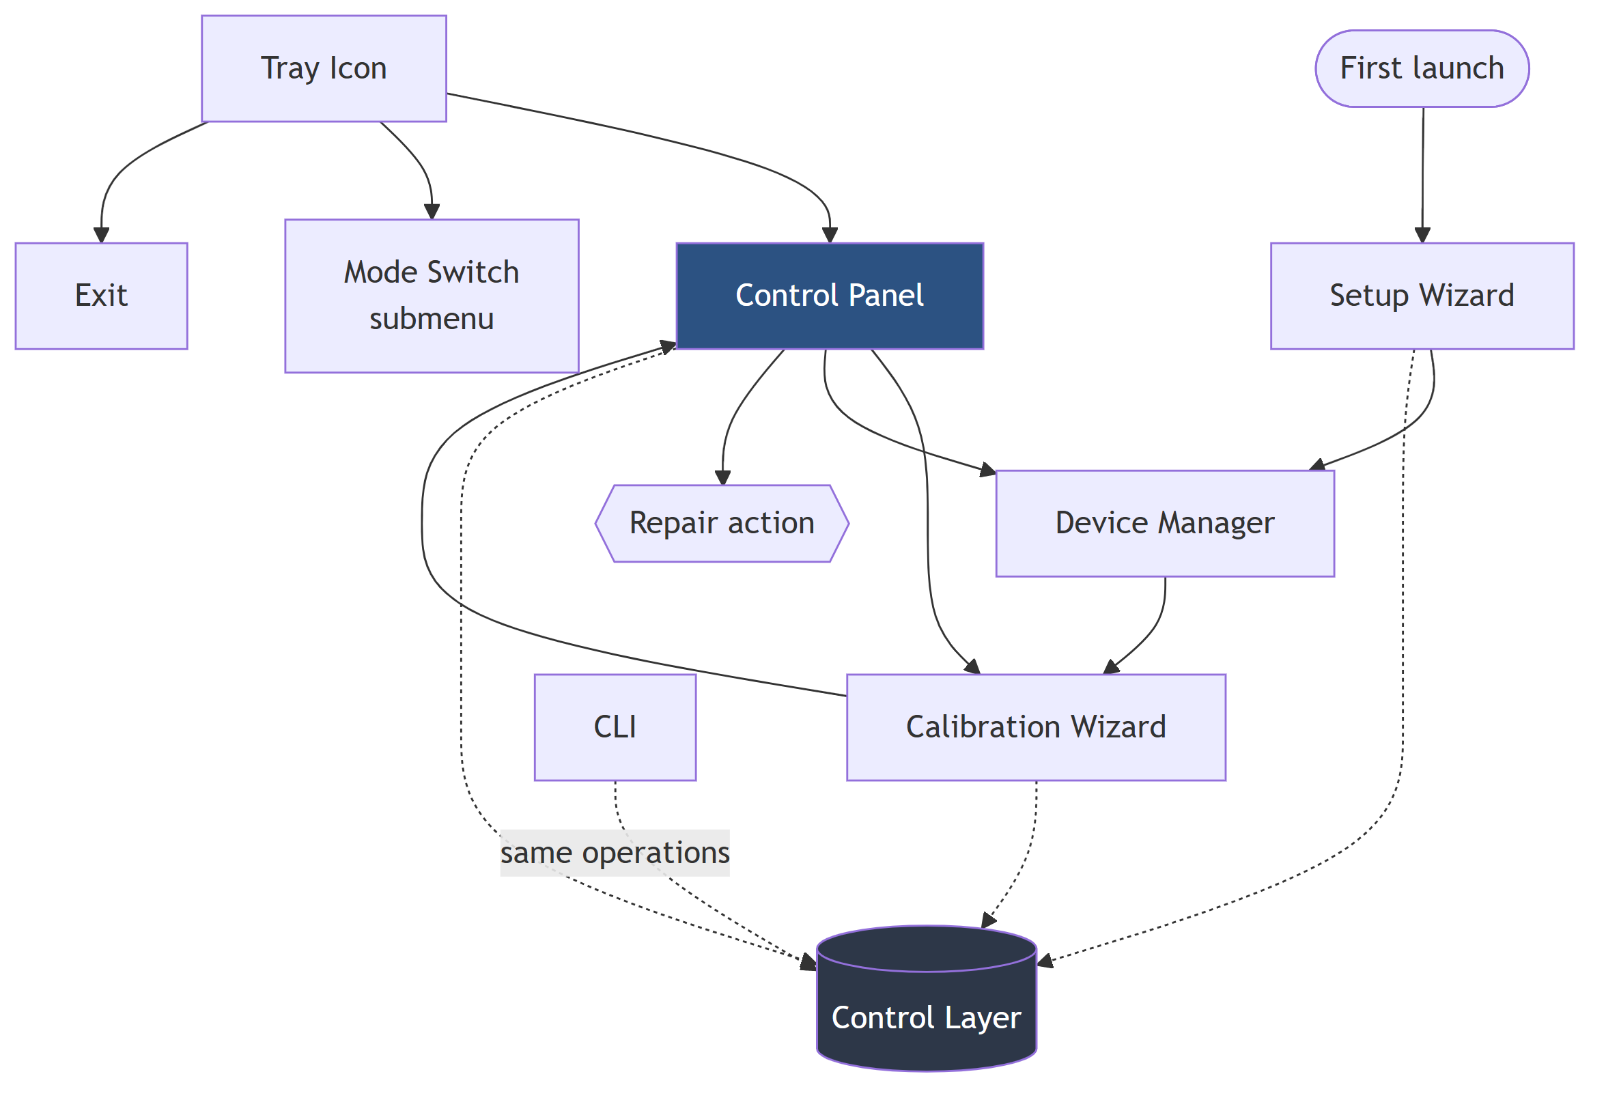
Figure 1. Surface Inventory

3. Control Panel
The primary surface. Always-on-top, minimisable to taskbar and tray, autostarts with the host.

3.1 Layout
┌─ Chorus ───────────────────────────────── ─ □ ✕ ┐
│ │
│ ALL ▓▓▓▓▓▓▓▓▓▓▓▓▓▓░░░░░░ -6 dB [M] │
│ ────────────────────────────────────────────── │
│ PartyPal 185 ▓▓▓▓▓▓▓▓▓▓░░░░░░░░░░ -12 dB [M] │
│ ● BT · 42 ms delay ▮▮▮▯▯ │
│ │
│ Stone 1400 ▓▓▓▓▓▓▓▓▓▓▓▓▓▓▓▓░░░░ -3 dB [M] │
│ ● BT · 0 ms delay ▮▮▮▮▯ │
│ │
│ Tab S9 FE+ ▓▓▓▓▓▓▓▓▓▓▓▓░░░░░░░░ -8 dB [M] │
│ ○ Miracast · not connected ▯▯▯▯▯ │
│ │
│ ────────────────────────────────────────────── │
│ Synced within 6 ms [Calibrate] [Fix] │
└──────────────────────────────────────────────────┘

3.2 Element specification
Element | Type | Behaviour | Range
Master slider (ALL) | Horizontal slider | Sets source strip gain; scales every output together | −40 … +6 dB
Output slider | Horizontal slider | Sets that output's bus gain only | −40 … +6 dB
dB readout | Label | Live value, updates during drag | Integer dB
[M] | Toggle button | Mutes that output without altering gain; red fill when engaged | on/off
Status dot | Indicator | ● connected · ○ disconnected · ◐ connecting | 3 states
Status line | Label | <transport> · <delay> ms delay, or the disconnect reason | text
Level meter (▮▮▮▯▯) | Meter | Live output level, confirms signal is actually reaching the device | 5 segments
Sync summary | Label | Residual spread from the last calibration, or Not calibrated | text
[Calibrate] | Button | Opens the Calibration Wizard | n/a
[Fix] | Button | Runs repair; enabled only when an output is Orphaned | n/a
The level meter earns its place: it is the only element that distinguishes "the app thinks this output is fine" from "sound is genuinely arriving at the device". During development, that distinction was repeatedly the difference between a real fault and a phantom one.

3.3 Row states
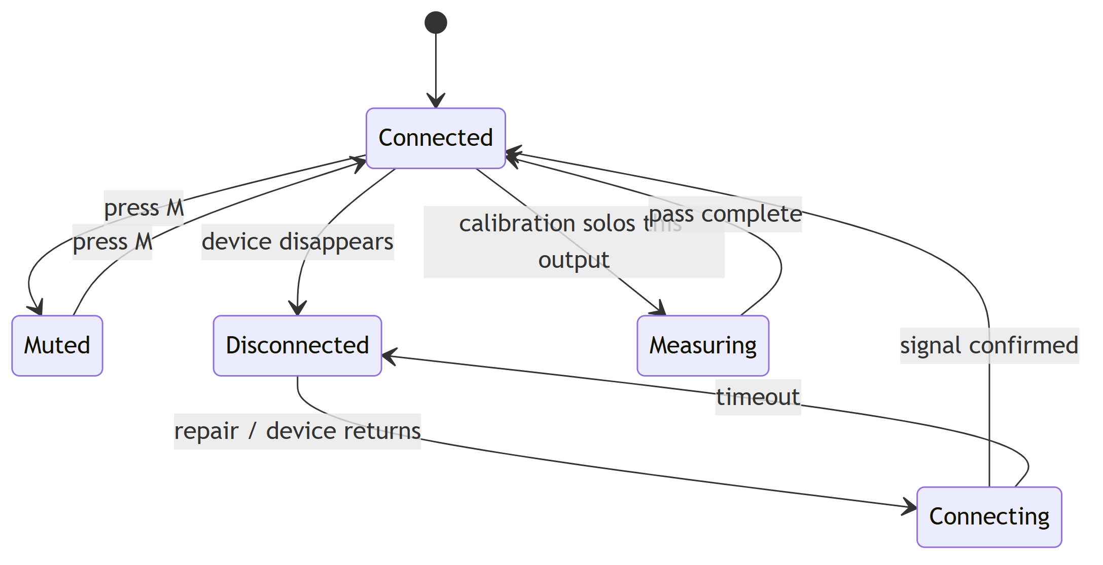
Figure 2. Row states
State | Dot | Slider | Status line
Connected | ● green | Enabled | BT · 42 ms delay
Muted | ● green | Enabled, [M] red | BT · muted
Disconnected | ○ grey | Disabled, dimmed | Miracast · not connected
Connecting | ◐ amber | Disabled | Reconnecting…
Measuring | ● blue | Disabled | Measuring…

3.4 Interaction rules
- Master and per-output gains are independent. The master scales the source; per-output gains trim relative balance. Moving the master never rewrites the individual values.
- A disconnected row keeps its settings. Gain, mute and delay persist so that reconnection restores the previous balance.
- [Fix] is enabled only when it can do something. Greyed out when no output is Orphaned, preventing pointless engine restarts.
- Writes show pending state. A control that has issued an engine write but not yet confirmed readback shows a subtle pending indicator; on failure the control reverts to its previous value and surfaces an inline message (P2).

4. Calibration Wizard
The flagship flow. Four steps, each with an explicit precondition check.
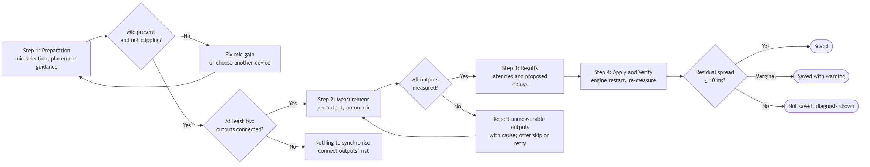
Figure 3. Calibration Wizard

4.1 Step 1: Preparation
┌─ Calibrate: Step 1 of 4 ────────────────────────┐
│ │
│ Microphone │
│ ┌────────────────────────────────────────────┐ │
│ │ Microphone (Realtek High Definition Audio)▾│ │
│ └────────────────────────────────────────────┘ │
│ Input level ▮▮▮▮▮▮▮▯▯▯ good │
│ │
│ Placement │
│ Put the microphone roughly the same distance │
│ from every speaker. The laptop between them │
│ is usually fine. │
│ │
│ ┌───┐ ┌─────┐ ┌───┐ │
│ │ 🔊│ ~2m │ 🎤 │ ~2m │🔊 │ │
│ └───┘ └─────┘ └───┘ │
│ │
│ Outputs to calibrate │
│ ☑ PartyPal 185 ● connected │
│ ☑ Stone 1400 ● connected │
│ ☐ Tab S9 FE+ ○ not connected │
│ │
│ This takes about 30 seconds per speaker and │
│ will play a clicking sound. │
│ │
│ [Cancel] [Start ▸] │
└──────────────────────────────────────────────────┘
Behaviour:
- Input level meter runs live; [Start] is disabled while the level reads clipping or silent.
- Disconnected outputs are shown but unchecked and unselectable, so the user sees why they are excluded.
- The duration and the audible-clicking warning are stated up front, because an unexplained clicking noise reads as a malfunction.

4.2 Step 2: Measurement
┌─ Calibrate: Step 2 of 4 ────────────────────────┐
│ │
│ Measuring PartyPal 185… │
│ │
│ ▓▓▓▓▓▓▓▓▓▓▓▓▓▓▓▓▓▓░░░░░░░░░░░░ 1 of 2 │
│ │
│ Captured onsets │
│ ▮ ▮ ▮ ▮ ▮ ▮ ▮ ▮ │
│ └─── 8 of 8 detected, phase stable ───┘ │
│ │
│ Only this speaker is playing right now. │
│ Please keep the room quiet. │
│ │
│ [Cancel] │
└──────────────────────────────────────────────────┘
Behaviour:
- Outputs are soloed in sequence; the currently measured output is named explicitly.
- Detected onsets appear live. This is deliberate: a user watching zero onsets appear learns immediately that the speaker is not audible, rather than waiting for a failure at the end.
- Phase stability is reported qualitatively beside the count, backed by the numeric IQR in the results step.

4.3 Step 3: Results
┌─ Calibrate: Step 3 of 4 ────────────────────────┐
│ │
│ Measured latency │
│ │
│ Stone 1400 ████████████████████ 218 ms │
│ PartyPal 185 ███████████████░░░░░ 176 ms │
│ ↑ │
│ 42 ms apart, audible │
│ │
│ Proposed correction │
│ ┌──────────────────────────────────────────┐ │
│ │ Stone 1400 0 ms (slowest, anchor) │ │
│ │ PartyPal 185 +42 ms │ │
│ └──────────────────────────────────────────┘ │
│ │
│ Applying this needs a short audio restart. │
│ │
│ [◂ Back] [Apply ▸] │
└──────────────────────────────────────────────────┘
Behaviour:
- Absolute latencies are shown, not only the difference, so the user can see that Bluetooth is inherently slow and that Chorus is not claiming to fix that.
- The anchor output is labelled as such, explaining why it receives no delay. This pre-empts "why did it only change one speaker?"
- The audio interruption is disclosed before it happens.

4.4 Step 4: Apply and Verify
┌─ Calibrate: Step 4 of 4 ────────────────────────┐
│ │
│ ✓ Delays written and verified │
│ ✓ Audio engine restarted │
│ ✓ Outputs re-connected │
│ ✓ Verification pass complete │
│ │
│ ┌──────────────────────────────────────────┐ │
│ │ Synced within 6 ms │ │
│ │ Below the 10 ms audible threshold. │ │
│ └──────────────────────────────────────────┘ │
│ │
│ Saved as profile "living-room". │
│ │
│ [Done] │
└──────────────────────────────────────────────────┘
The checklist mirrors the real sequence from TRD §5.4, including the re-connection step that exists because engine restarts drop bus assignments. Showing it builds justified confidence: each line is a verified fact, not a progress animation.

4.5 Failure presentation
┌─ Calibrate, Could not complete ─────────────────┐
│ │
│ Stone 1400: no sound detected │
│ │
│ The measurement heard nothing from this │
│ speaker. Likely causes: │
│ │
│ • Speaker volume set very low │
│ • Speaker too far from the microphone │
│ • Speaker connected but not playing │
│ (level meter shows no signal) │
│ │
│ PartyPal 185 measured fine at 176 ms. │
│ │
│ Nothing was changed. │
│ │
│ [Retry] [Skip this output] [Close]│
└──────────────────────────────────────────────────┘
Rules for failure screens:
- Name the specific output and the specific symptom.
- List causes in descending order of likelihood, drawn from the observed failure modes (TRD §8).
- State explicitly what did succeed, so the user knows the scope of the problem.
- State explicitly that nothing was changed. A failed calibration must never leave partial delays applied.

5. Setup Wizard (first run)
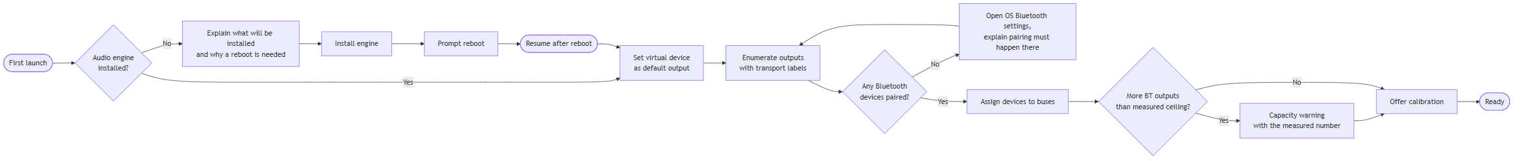
Figure 4. Setup Wizard (first run)
Pairing deliberately delegates to the operating system rather than reimplementing a Bluetooth pairing UI: the OS flow is more reliable, already familiar, and handles PINs and device quirks.

6. Tray Icon
Element | Behaviour
Icon | Reflects session state: Ready (normal), Degraded (badge), Calibrating (animated)
Left click | Show/hide Control Panel
Right click | Context menu
Tooltip | Chorus: 2 of 3 outputs active
┌──────────────────────────┐
│ Show Control Panel │
│ ────────────────────── │
│ Mode ▸ ● Theatre (all) │
│ ○ PartyPal only │
│ ○ Stone only │
│ ○ Laptop only │
│ ────────────────────── │
│ Calibrate… │
│ Fix outputs │
│ ────────────────────── │
│ Exit │
└──────────────────────────┘

7. CLI Surface
The CLI is the complete API; the GUI is a client of it (P5).
Command | Purpose | Output
chorus status | Session state, per-bus device, transport, signal, delay | Table
chorus devices [--scan] | Available outputs with transport type | Table
chorus assign <bus> <device> | Assign device to bus | Confirmation, verified
chorus route <bus> on|off | Enable/disable routing | Confirmation
chorus gain <bus> <db> | Set bus gain | Confirmation
chorus mute <bus> on|off | Mute a bus | Confirmation
chorus mode <name> | Switch output mode | Confirmation
chorus calibrate [--profile <name>] [--mic <device>] | Run calibration | Progress + result table
chorus delay <bus> <ms> | Manually override delay | Confirmation, verified
chorus repair | Re-assert assignments, restart engine | Per-bus result
chorus diagnose | Transport, contention, stream count report | Report
chorus config show|edit|validate | Config management | JSON / validation result
Example output:
$ chorus status
Session: Ready Profile: living-room
Engine: Voicemeeter Potato 3.1.2.2 Buffer: 1024 (WDM)
BUS DEVICE TRANSPORT ROUTE GAIN DELAY SIGNAL
A1 PartyPal 185 BT A2DP on -12 dB 42 ms ▮▮▮▯▯
A2 Stone 1400 BT A2DP on -3 dB 0 ms ▮▮▮▮▯
A3 Tab S9 FE+ Miracast on -8 dB, ms ───── orphaned
Last calibration: 2026-08-25 18:04 residual spread 6 ms PASS
Conventions:
- Exit code 0 success, 1 user error, 2 engine/verification failure, 3 calibration failure.
- --json on any command emits machine-readable output for automation.
- Every mutating command prints the verified post-state, never merely "OK".

8. Feedback and Messaging
Situation | Surface | Pattern
Output dropped | Panel row + tray badge | Passive state change; no modal
Calibration finished | Wizard step 4 | Numeric result with threshold comparison
Engine write failed | Inline at the control | Control reverts; message names the parameter
Capacity warning | Assignment step | States the measured ceiling and that exceeding it is untested
Nothing to do | Disabled control + tooltip | Explain why it is disabled
Prohibited patterns: modal dialogs for routine wireless drops; progress bars that do not reflect real progress; success messages issued before readback verification; and any adjective about audio quality unaccompanied by the measured number (P4).

9. Accessibility and Ergonomics
Requirement | Implementation
Keyboard operable | Tab order follows visual order; sliders respond to arrow keys (±1 dB) and Page Up/Down (±5 dB)
Not colour-dependent | Status uses shape (●/○/◐) plus text, not colour alone
Readable at high DPI | Layout uses relative units; verified at 250% scaling, the reference platform runs at 250%
Screen-reader labels | Every control carries an accessible name including its current value
Minimum target size | 32 × 32 px for buttons
The high-DPI requirement is specific and non-negotiable: the reference platform runs at 250% scaling, and an earlier attempt to enlarge a fixed-size third-party window by DPI-stretch produced a window larger than the screen. The panel must scale natively rather than being stretched.

10. Deferred UI Work
Item | Reason deferred
Per-output equalisation | Out of scope for v1 (PRD W-3)
Visual room layout editor with distances | Depends on distance compensation (FR-2.8, v0.3)
Calibration history graph | Needs logging (FR-4.3) to accumulate data first
Drag-and-drop bus assignment | Text assignment is sufficient and scriptable
Dark/light theming | Follow OS default initially

